**COVID AND TESTING**

By: Percy Brown

15th December 2020.

Up till now, is there a relationship between GDP per capita and the ability to test for COVID-19 effectively? Several countries are using unique ways of containing the spread of coronavirus. Although strategies such as observing lockdowns and testing are commonly used, they differ among countries significantly. In this article, I analyse how countries use lockdowns and testing capabilities to contain the spread of the virus, and then subsequently explore the relationship between a country's GDP per capita and their ability to conduct more COVID tests using data from *Our World in Data* as at 15th November 2020.

How are continents using testing and lockdown to fight COVID? The figure below shows a scatter plot for each continent’s average stringency index and test efficiency. The stringency index is a composite measure based on nine response indicators including school closures, workplace closures, and travel bans among others, rescaled to a value from 0 to 100 (100 = strictest). The test efficiency assumes that a continent tests more efficiently if it carries out more tests per positive cases. The points represent the various continents and the line describes the linear relationship between average stringency index and test efficiency.

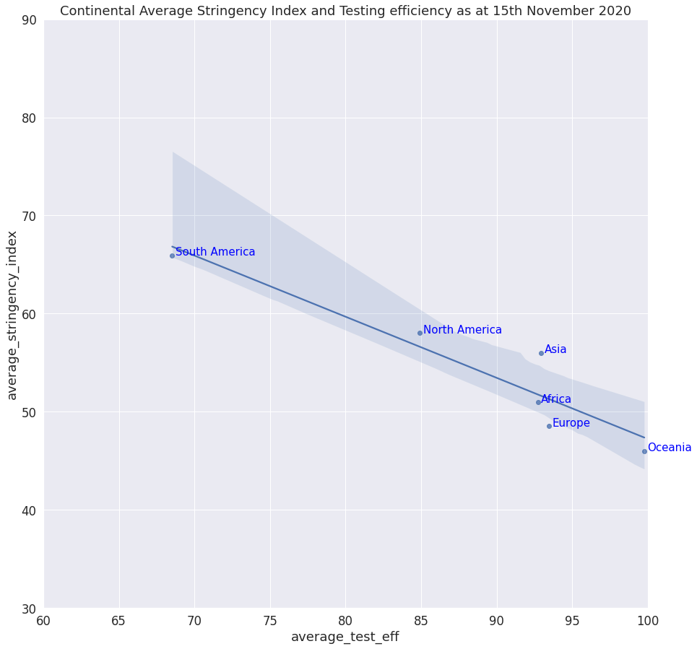

There appears to be an inverse relationship between continents’ average testing efficiency and stringency index (lockdown). Continents that rely less on lockdowns tend to have higher average test efficiency, while continents with higher average stringency index have a lower test efficiency. As at 15/11/2020, Oceania leads with the highest average test efficiency of approximately 100, with the lowest average stringency index of about 56%. South America, on the other hand, has the highest average stringency index of approximately 68%, has the lowest average test efficiency. Europe, Asia and Africa have approximately the same average test efficiency of about 93, but have different average stringency indexes, indicating the uniqueness of the approaches taken by each continent.

Is a country’s GDP per capita a determining factor in its ability to test its citizens? The figure below shows a scatter plot of GDP per capita and the number of tests per thousand citizens. The points represent the various countries across the world and the line describes the linear relationship between GDP per capita and the total tests per thousand population.

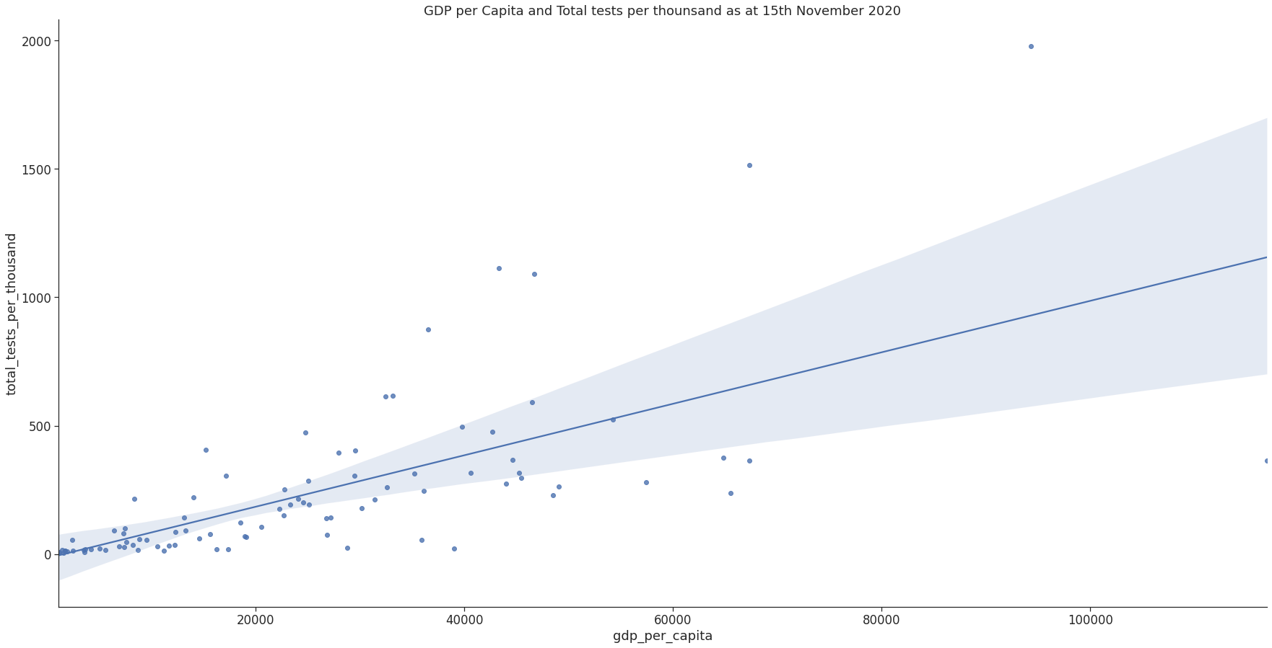

There appears to be a positive relationship between a country’s GDP per capita and its ability to test citizens. Countries with less GDP per capita are more likely to conduct fewer tests per thousand population than countries with high GDP per capita, with few exceptions. For instance, countries with GDP per capita of approximately 20,000 conduct less than 500 tests per thousand population. Some countries with GDP per capita of 40,000 tests more per thousand population as compared to countries with a higher GDP of 60,000, while other countries with GDP of about 65,000 and can conduct more tests per thousand population.

For more exploration of the data, kindly visit [data](https://github.com/owid/covid-19-data/tree/master/public/data).

Also find the colab notebook available [here](https://colab.research.google.com/drive/1bPSNyQ4p_4NlREuCFHRO33DW6oSKweEN#scrollTo=OregjndX_PoK) under the [MIT License](https://en.wikipedia.org/wiki/MIT_License).